
TECHNICAL RIDER

INSTRUMENTS

- Drums
- Guitar – Helix Rack Unit (No Amp)
- Bass – Boss Pedal (No Amp)

IN EAR MONITORS (IEM RACK)

1 | Kick | 9 | Bass
2 | Snare | 10 | Guitar - Left
3 | N/A | 11 | Guitar - Right
4 | N/A | 12 | Vocals (Jess)
5 | 12” Tom | 13 | Vocals (Guitar)
6 | 14” Floor | 14 | Vocals (Drums)
7 | 16” Floor | 15 | Vocals (Bass)
8 | Hi-Hats | 16 | Talk Back

SPECIAL NOTES

- Guitar – 2 XLR outputs to DI boxes (Stereo).
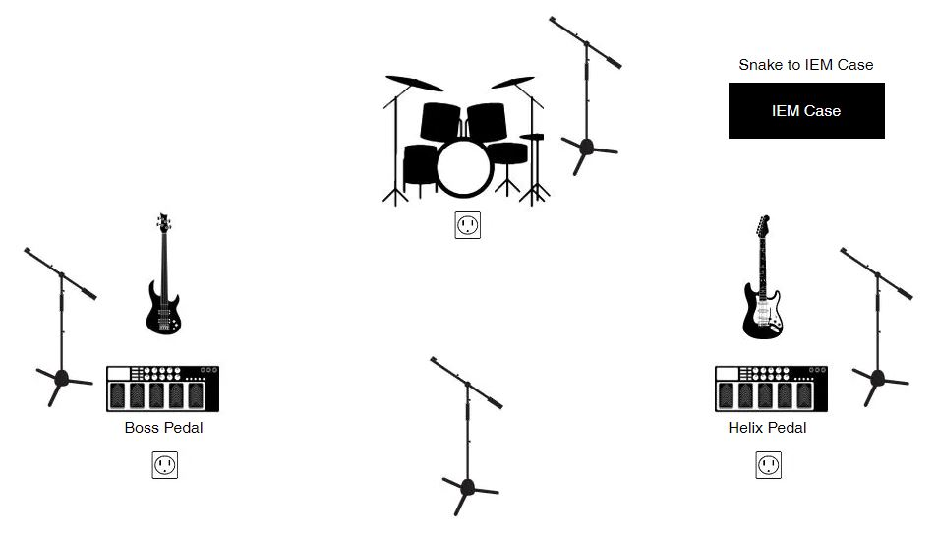
- Bass – 1 XLR output from pedal to DI Box

